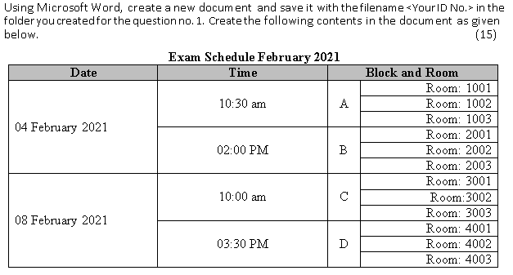
- Create a folder on your desktop by your ID and save all the documents in this folder. (10)
2.

3. Create a workbook with <your ID> and save it into the folder and then create the spreadsheet by following data and calculate the following condition. (25)
ID | MCQ | DESCRITIVE | TOTAL | RESULT
101 | 45 | 35
102 | 50 | 48
103 | 25 | 30
104 | 20 | 15
105 | 35 | 25

If total grater or equal to 60% then result will be pass otherwise fail. Those who are fail the text will be red.

